Project Design Phase-II

Customer Journey Map

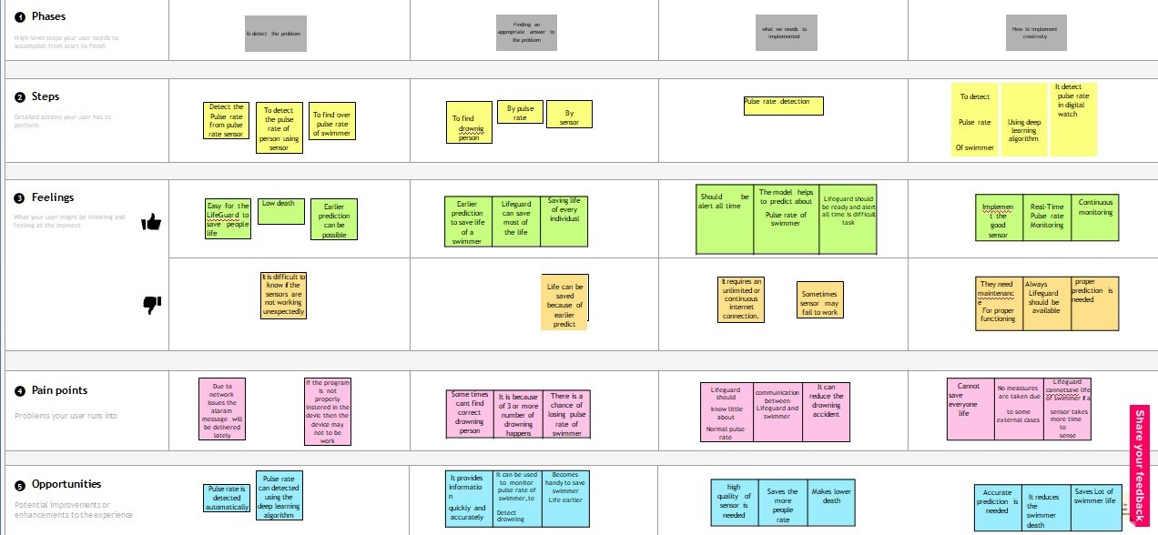

|  |  |
| --- | --- |
| Date | 22 October 2022 |
| Team ID | PNT2022TMID45727 |
| Team Leader | Vivek.s |
| Team Member | Kaviya , aathidevan , sabitha |
| Project Name | Virtual Eye – Lifeguard for Swimming Pools for Active Drowning |
| Maximum Marks | 2-Marks |